|  |  |  |
| --- | --- | --- |
| **Noble Huang (Mulia Widjaja)** | | |
| **SANTA CLARA UNIVERSITY** | **ELEN 115 – Spring 2023** | **S. Krishnan** |
|  | **Homework #6** |  |

5. The regulator in Figure 5 employs a zener diode DZ that is specified to have a 8V drop at a test current of 25mA with rz =10Ω and IZK =0.2mA.

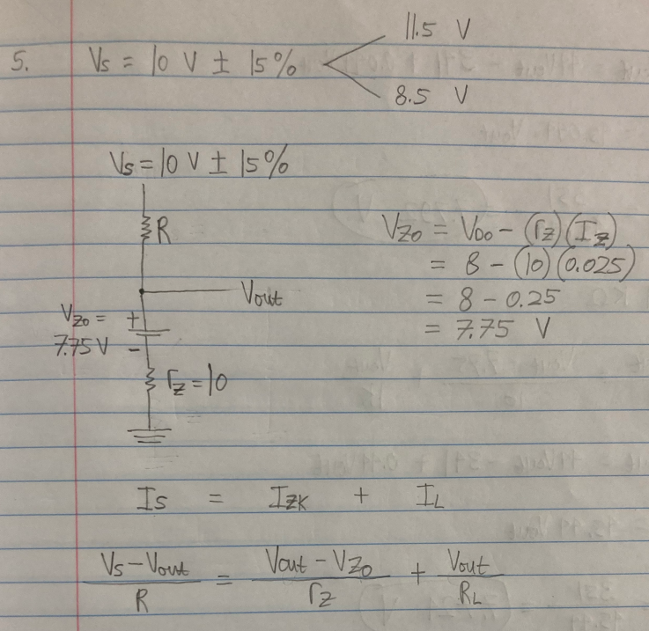

1. Find **the value of R** needed to obtain an output voltage Vout = 7.8V at nominal supply voltage Vs and no load.

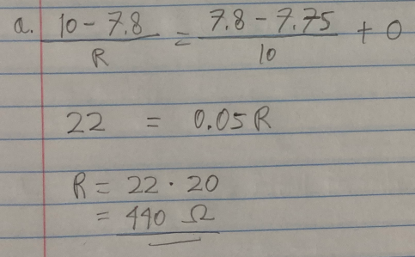

1. With the value of R as obtained in (a) and nominal Vs find the **value of Vout** with a load resistance of



D

Z



R



Vs = 10V

±

15%



V

out

* 1. RL= 10kΩ

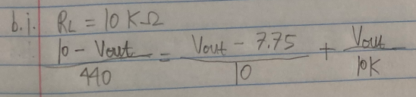

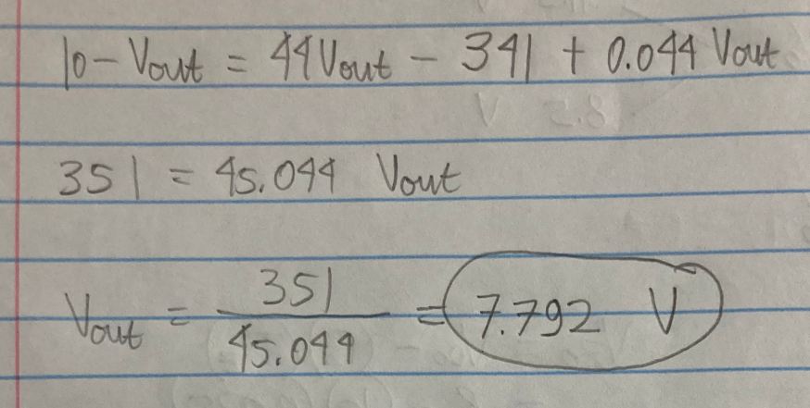

* 1. RL= 1kΩ

